Smart Lender – Loan Eligibility Prediction System
2. Defining the Application Architecture
2.1 Introduction
Application architecture defines the overall structure of the Smart Lender system and explains how different components work together to perform loan prediction. A well-designed architecture improves the application's organization, maintainability, and performance. In this project, the application follows a simple workflow where the user submits loan details through a web interface, the Flask backend processes the request, the trained machine learning model predicts the result, and the prediction is displayed back to the user.
2.2 Objective
The objective of this task is to understand the architecture of the Smart Lender application, identify the role of each project component, and define the interaction between the frontend, backend, dataset, and machine learning model.
2.3 Application Architecture
The Smart Lender application consists of the Dataset, HTML pages, Flask backend, and a Machine Learning model. The user enters loan details through the web interface, which are processed by the Flask application. The trained machine learning model predicts whether the loan will be approved or rejected, and the result is displayed to the user.
Figure 2.1: Machine Learning Workflow of the Smart Lender Application
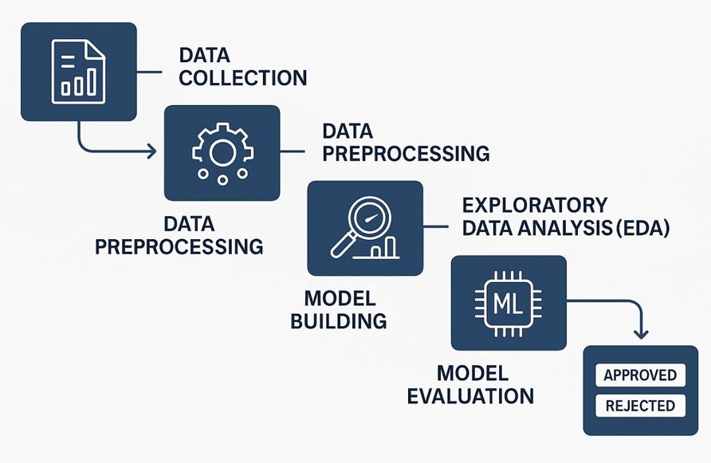

2.4 Implementation
The project architecture was studied using the SmartBridge reference structure. The folders and files were examined to understand their responsibilities within the application. The interaction between the frontend, backend, dataset, and trained model was analyzed to understand how the complete loan prediction process is executed.
2.5 Outcome
The application architecture was successfully understood. The project structure, file organization, and data flow were clearly identified, providing a strong foundation for the development and execution of the Smart Lender application.

